MeM

Biography
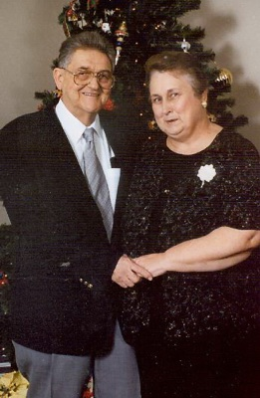

Mr. Donald James Teachman
Born:
May 6, 1934
Died:
January 9, 2007

Memorialized by:
Bryant Funeral Home, Franklin, NC
Donald James Teachman, age 72, of Oak Forest Lane, Franklin, NC passed away Tuesday, January 09, 2007 at his residence. He was born, May 6, 1934 in Dumont, New Jersey, the son of the late James and Martha McLardy Teachman.
He was the owner of Don's Village Market in Scaly Mountain for 23 years. Under his management, it grew from a small store to include gas, groceries and hardware. Don always enjoyed the coffee crowd in the morning. He met wonderful people while in business there. He was one of the founding members of the Scaly Mountain Volunteer Fire Department. He was a Braves baseball fan, loved to watch football, and was a great armchair quarterback.
He is survived by his wife, Dorothy E. Teachman; two daughters, Noreen Cyphers, and her husband Cliff of Franklin, NC, Lisa Miller and her husband Dale of Scaly Mountain, NC; two sons, Donnie Teachman and his wife Maria of Jacksonville, FL, and Jim Cook, of Boynton Beach, Florida; one sister, Dorothy Fleenor, of Florida; one brother, Dorward Teachman of Florida; eight grandchildren, Donnie Jr., Michelle, Zachary, Luke, Morgan, Amanda, James and Joseph; and one great-grandson, Dane also survives. He was preceded in death by a son, Jeff Cook, and a brother, Harry Teachman.
Funeral services will be held Saturday, January 13th at 1:00pm in the Chapel of Bryant Funeral Home, with Rev. Dwight Loggins officiating. Burial will be in Woodlawn Cemetery. The family will receive friends from 6:00 to 8:00pm Friday evening at Bryant Funeral Home.
In lieu of flowers, donations to Westcare Hospice, 132 Sylva Plaza, Sylva, NC 28779, or Scaly Mountain Fire Department, PO Box 278, Scaly Mtn., NC 28775, would be appreciated.
Bryant Funeral Home is in charge of arrangements.

